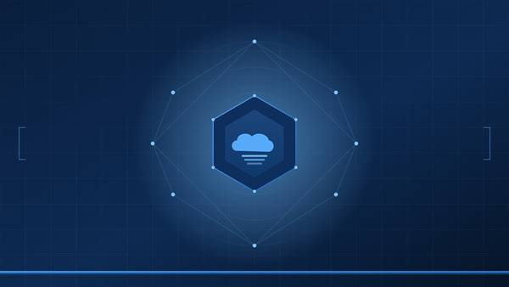
TECHNICAL ADVISORY · PRIVATE CLOUD OPERATIONS
<Project Name>
<VCF Version> / <VCF Automation Version>

Implementation Guide
PREPARED: <Month Year> · AUDIENCE: <customer>, <groups>

0. Read This First
Package-based deployment
<Describe how the solution is distributed (package file, manual build, etc.) and what the package contains. Set expectations for deployment time.>
<Estimated deployment time and observation window recommendation.>

1. Prerequisites

1.1 Platform
Component | Required
VMware Cloud Foundation | <version>
Embedded VCF Orchestrator | <version>
vCenter Server | <version> (one or more, all registered with VCF Orchestrator)
VCF Operations for Logs | Recommended

1.2 Privileges
<List the minimum privileges the VCF Orchestrator service account needs on each target system.>
- <Privilege 1>
- <Privilege 2>
- <Privilege 3>

1.3 Skills and Access
- <Required role/access 1>
- <Required role/access 2>
- <Required role/access 3>

1.4 Obtain the Package
<How to get the package file and where to stage it.>

2. Package Contents
<Table listing every object in the package so the implementer knows what to expect after import.>
Type | Name | Description
Workflow | <workflow name> | <Description>
Action Module | <com.broadcom.pso.xxx> | <Actions contained>
Configuration Folder | <folder path> | <Configuration elements contained>

3. Step 1 — Import the Package
<Step-by-step import instructions specific to VCF Orchestrator UI. Include conflict resolution guidance for upgrades.>
Import does not overwrite configuration element values
<Reassure the implementer that runtime state is preserved during upgrade imports.>
After import completes, verify the objects exist:
<List exact navigation paths to each imported object.>

4. Step 2 — Post-Import Configuration
<List every item that requires environment-specific configuration after import.>

4.1 Initialize Configuration Elements
<Table of configuration element attributes with their required initial values.>
Attribute | Type | Required Value | Notes
<attribute> | <type> | <value> | <Why this value matters>
<attribute> | <type> | <value> | <Notes>
Upgrade installs: skip this step
<Note that existing installations already have these values populated.>

4.2 Review Workflow Defaults
<Table of all configurable parameters with their defaults and guidance.>
Input | Type | Default | Notes
<parameter> | <type> | <default> | <Guidance>
dryRun | boolean | true | MUST remain true as the default.

5. Step 3 — Configure the Schedule
<How to set up the recurring schedule, including recommended timing and input overrides.>
Stagger across environments
<Guidance on staggering schedules if deployed to multiple VCF Orchestrator instances.>

6. Step 4 — Smoke Test

6.1 Manual Dry Run
<Step-by-step instructions for running the first test. Include expected log output.>

6.2 Verify State Cleanup
<How to confirm runtime state (locks, temp data) was released cleanly.>

6.3 Verify Log Ingestion
<How to confirm logs are appearing in VCF Operations for Logs.>

7. Going Live
<Step-by-step process for transitioning from dry-run observation to live execution. Include the recommended observation period at each stage.>

8. Verification Checklist
# | Item | Verified?
1 | <Checklist item 1>
2 | <Checklist item 2>
3 | <Checklist item 3>
4 | <Checklist item 4>
5 | <Checklist item 5>
6 | <Checklist item 6>

9. Upgrading
<Step-by-step upgrade procedure. Include pre-flight checks and post-upgrade validation.>
Runtime state is preserved
<Reassure implementers that operational history is retained across upgrades.>

10. Rollback
<How to completely remove the solution from the environment. Include data-loss warnings where applicable.>

